- Construct a tangents at a given point c on the circumference
- Draw tangent to a circle from point p outside the circle
RATIONALE
Knowledge: Tangents to a point on and away from the circumference,
Skills: Manipulation, Accuracy, Drawing, Demonstration
Values: Appreciation, Curiosity, Application, Logical thinking, Problem solving, Quality work
TEACHING AIDS
……………………………………………………………………………………………………………………………………………

PART | LESSON CONTENT | METHODOLO GY | LEARNER ACTIVITY
introduction | - Recap on the previous lesson | Questions and answers | Provide answers
Developme nt | TANGENT  Tangent is the straight line touching the circumference of a circle.  CONSTRUCT A TANGENTS AT A GIVEN POINT C ON THE CIRCUMFERENCE  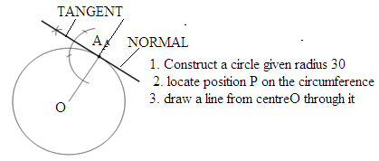  DRAW TANGENT TO A CIRCLE FROM POINT P OUTSIDE THE CIRCLE  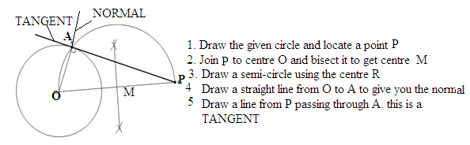 | Questions And Answers  Demonstration  V/E | Taking note of important points  Provide answers
Application | CLASS EXERCISE  - Define tangent?  - Construct a tangents at a given point c on the circumference Q60  - Draw tangent to a circle from point p outside the circle Q60 | Questions And Answers | Provide answers
Conclusion | - Recap on the main steps and points | V/E
LESSON EVALUATION

TEACHER: MWALE CHIPO

KENNETH KAUNDA SECONDARY SCHOOL DESIGN AND TECHNOLOGY DEPARTMENT
LESSON PLAN

SUBJECT: DESIGN AND TECHNOLOGY CLASS:…… … DATE:……/……./20…. DURATION:………….
BOYS:…………………… GIRLS ………………………………………. TOTAL OF PUPILS… TOPIC: CIRCLES SUBTOPIC: TANGENTS
LEARNING OUTCOMES LSBAT
  - Draw a common external tangent to two equal circle Q60 mm
  - Draw a common internal tangent to two equal circle of Q60 mm
RATIONALE
Knowledge: Internal /external tangents to equal circles.
Skills: Manipulation, Accuracy, Drawing, Demonstration
Values: Appreciation, Curiosity, Application, Logical thinking, Problem solving, Quality work
TEACHING AIDS
……………………………………………………………………………………………………………………………………………

PART | LESSON CONTENT | METHODOLO GY | LEARNER ACTIVITY
introduction | - Recap on the previous lesson | Questions and answers | Provide answers
Developme nt | TANGENTS  DRAW A COMMON EXTERNAL TANGENT TO TWO EQUAL CIRCLE Q60 MM  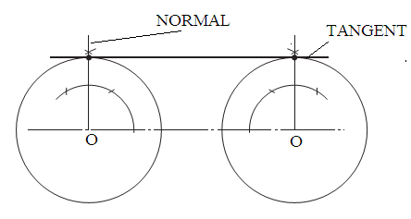  DRAW A COMMON INTERNAL TANGENT TO TWO EQUAL CIRCLE OF Q60 MM  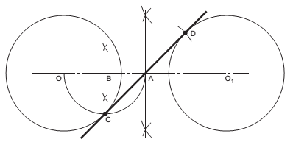 | Questions And Answers  Demonstration  V/E | Taking note of important points  Provide answers
Application | CLASS EXERCISE  - Draw a common external tangent to two equal circle Q60 mm  - Draw a common internal tangent to two equal circle of Q60 mm | Questions And Answers | Provide answers
Conclusion | - Recap on the main steps and points | V/E
LESSON EVALUATION

TEACHER: MWALE CHIPO.

DESIGN AND TECHNOLOGY DEPARTMENT
LESSON PLAN

SUBJECT: DESIGN AND TECHNOLOGY CLASS:…… … DATE:……/……./20…. DURATION:………….
BOYS:…………………… GIRLS ………………………………………. TOTAL OF PUPILS… TOPIC: CIRCLES SUBTOPIC: TANGENTS
LEARNING OUTCOMES LSBAT
- Draw a common external tangent to two unequal circle Q50 and Q70
RATIONALE
Knowledge: external tangents to unequal circles.
Skills: Manipulation, Accuracy, Drawing, Demonstration
Values: Appreciation, Curiosity, Application, Logical thinking, Problem solving, Quality work
TEACHING AIDS
……………………………………………………………………………………………………………………………………………

PART | LESSON CONTENT | METHODOLO GY | LEARNER ACTIVITY
introduction | - Recap on the previous lesson | Questions and answers | Provide answers
Developme nt | TANGENTS  DRAW A COMMON EXTERNAL TANGENT TO TWO UNEQUAL CIRCLE Q50 AND Q70  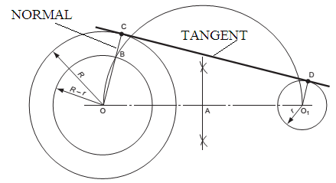  - Join the centres OO  - Bisect OO1 in A and draw a semi-circle, radius AO.  - Draw a circle, centre O, radius R- r, to cut the semi-circle in B.  - Join OB and produce to cut the larger circle in C.  - Draw O1 D parallel to OC. CD is the required tangent. | Questions And Answers  Demonstration  V/E | Taking note of important points  Provide answers
Application | CLASS EXERCISE  Draw a common external tangent to two unequal circle diameters 50 and 70 O1-O= 120 | Questions And Answers | Provide answers
Conclusion | - Recap on the main steps and points | V/E
LESSON EVALUATION

TOPIC: CIRCLES SUBTOPIC: TANGENTS
LEARNING OUTCOMES LSBAT
- Draw a common internal tangent to two unequal circles Radius 35 and Radius 25
RATIONALE
Knowledge: internal tangents to unequal circles.
Skills: Manipulation, Accuracy, Drawing, Demonstration
Values: Appreciation, Curiosity, Application, Logical thinking, Problem solving, Quality work
TEACHING AIDS
……………………………………………………………………………………………………………………………………………

PART | LESSON CONTENT | METHODOLO GY | LEARNER ACTIVITY
introduction | - Recap on the previous lesson | Questions and answers | Provide answers
Developme nt | TANGENTS  DRAW A COMMON INTERNAL TANGENT TO TWO UNEQUAL CIRCLES RADIUS 35 AND RADIUS 25  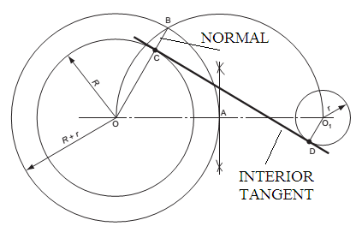  - Join the centres OO1  - Bisect OO 1 in A and draw a semi-circle, radius OA.  - Draw a circle, centre O, radius R-r, to cut the semi-circle in B.  - Join OB. This cuts the larger circle in C.  - Draw O1 D parallel to OB.  - CD is the required tangent | Questions And Answers  Demonstration  V/E | Taking note of important points  Provide answers
Application | CLASS EXERCISE  Draw a common internal tangent to two unequal circles radius 35 and radius 25 | Questions And Answers | Provide answers
Conclusion | - Recap on the main steps and points | V/E
LESSON EVALUATION

TOPIC: CIRCLES SUBTOPIC: CIRCLES IN CONTACT
LEARNING OUTCOMES LSBAT
- Draw internal arc, to join the two circles
- Draw an internal arc to two circles of unequal diameters ( 50 and 30)
- Draw an external arc to two circles of unequal diameters ( 50 and 30)
RATIONALE
Knowledge: Radius corners Circles in contact (Internal / external to two equal and unequal circles)
Skills: Manipulation, Accuracy, Drawing, Demonstration
Values: Appreciation, Curiosity, Application, Logical thinking, Problem solving, Quality work
TEACHING AIDS
……………………………………………………………………………………………………………………………………………

PART | LESSON CONTENT | METHODOLO GY | LEARNER ACTIVITY
introduction | - Recap on the previous lesson | Questions and answers | Provide answers
Developme nt | TANGENTIAL ARCS  Draw an internal arc to two circles of unequal diameters ( 50 and 30)  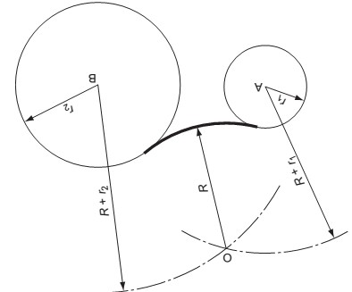  Draw an external arc to two circles of unequal diameters ( 50 and 30)  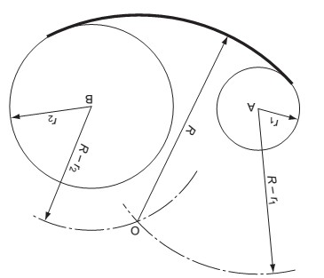 | Questions And Answers  Demonstration  V/E | Taking note of important points  Provide answers
Application | CLASS EXERCISE  Draw an internal arc to two circles of unequal diameters ( 50 and 30) Draw an external arc to two circles of unequal diameters ( 50 and 30) | Questions And Answers | Provide answers
Conclusion | - Recap on the main steps and points | V/E
LESSON EVALUATION

CLASS: DATE;

- Figure 6 shows the outlines of three pulley wheels connected by a taut belt. Draw the figure, full size, showing clearly the constructions for obtaining the points of contact of the belt and pulleys
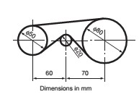

- Figure 3 shows the outline of two pulley wheels connected by a belt of negligible thickness. Draw the figure showing the construction necessary to obtain the points of contact of the belt and pulleys
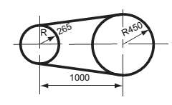
- Figure 7 shows the outline of a metal blank. Draw the blank, full size, showing clearly the constructions for finding exact positions of the tangents joining the arcs.
